Stem cell breakthrough boosts Australian biotech firm
By business reporter Emily Stewart Posted yesterday 18.02.2014. at 2:40am
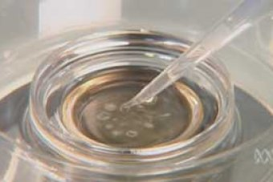PHOTO: Stem cells are currently difficult to produce in large quantities. (ABC TV)
Painful bone marrow or fat tissue donations may soon be a thing of the past after an Australian biotech company made a breakthrough in the manufacturing of stem cells.
ASX-listed Cynata Therapeutics will mass manufacture mesenchymal stem cells (adult stem cells typically found in bone marrow) from just one blood donation.
These stem cells are particularly useful in treating a wide range of diseases including stroke, auto-immune diseases and spinal cord injuries.
"Current methods of manufacture rely on donors donating either their bone marrow, which is a painful and risky procedure, or fat tissue which is similarly risky, and the diversity of cells obtained that way means clinical outcomes are very very different," said the firm's chief executive Dr Ross Macdonald.
"If we're talking about widespread diseases of economic importance like stroke for instance then we need a very large source and lots and lots of cells. The only way of achieving that is through our process."
The method is built on a decade of research from the University of Wisconsin and has been successfully validated at Waisman Biomanufacturing.
Human clinical trials are soon to begin and the company is in discussions with regulatory authorities.
"At this stage we haven't spent lot of time assessing the regulatory framework in Australia. The markets in the US, Europe and Asia are far more attractive, but Australia will certainly follow," said Dr Macdonald.

